A **moving average (MA)** smooths out fluctuations over time, helping to detect trends.

**How to Implement:**

1. **Choose the Window Size:**
   * **Short-term (3 months)** → Detects quick changes but may be noisy.
   * **Medium-term (6 months)** → Balances sensitivity and stability.
   * **Long-term (12 months)** → Best for long-term trend detection.
2. **Compute the Moving Average:**
   * 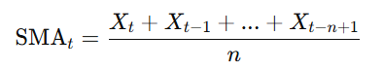Formula for a **Simple Moving Average (SMA)**:

where:

* + - Xt​ is the current metric value (e.g., Alert Rate for the current quarter).
    - n is the number of periods (e.g., 3, 6, or 12 months).

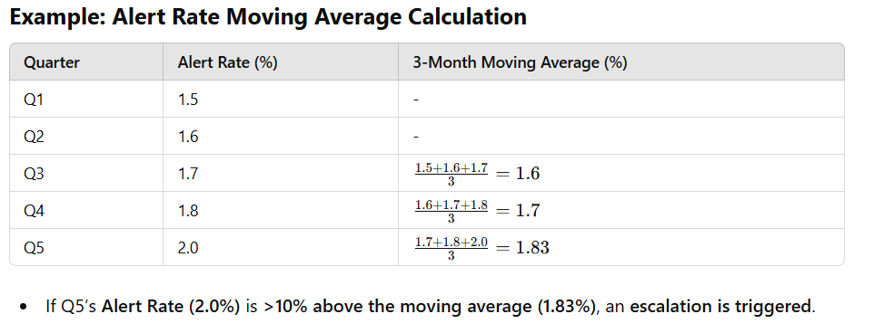

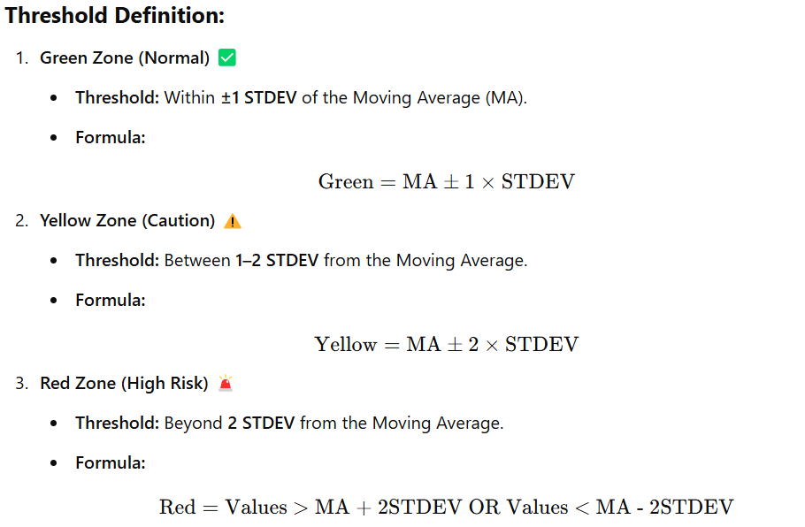

**Compute Thresholds for Green, Yellow, and Red**

* **Green ✅** → Within ±1 STDEV from Moving Average
* **Yellow ⚠️** → Between ±1 STDEV and ±2 STDEV
* **Red 🚨** → Beyond ±2 STDEV (high risk)

**Why is Standard Deviation (STDEV) Used for Thresholds?**

Standard Deviation (STDEV) is used to account for natural variability which fluctuates due to transaction volume, fraud trends, and model adjustments.

By measuring the typical range of variation, STDEV prevents overreaction to minor fluctuations. It also enables data-driven threshold setting, ensuring that green, yellow, and red levels are based on statistical significance rather than arbitrary values. If FPR exceeds **2 STDEV**, it signals an unusual deviation that may require further investigation. Additionally, STDEV dynamically adjusts as new data becomes available, ensuring that thresholds remain relevant as fraud patterns evolve.

**The Rationale for Threshold selection (±1 STDEV or Between ±1 and ±2 STDEV or Beyond ±2 STDEV)**

Standard deviation helps categorize metrics variations based on expected statistical behavior.

The choice of **±1 STDEV (Green), ±1 to ±2 STDEV (Yellow), and beyond ±2 STDEV (Red)** is based on widely accepted statistical conventions and practical application in monitoring variations. This standard approach ensures a balance between detecting meaningful deviations and avoiding overreactions to minor fluctuations.

1️. **Within ±1 STDEV (Green):** This range captures expected, natural fluctuations, ensuring normal variations don’t trigger unnecessary alarms. Expanding it to ±1.5 STDEV might delay early warnings of emerging issues.

2️. **Between ±1 and ±2 STDEV (Yellow):** This acts as an early warning system for moderate deviations. Using **±1.5 to ±2.5 STDEV** would reduce sensitivity, potentially missing important shifts in fraud patterns.

3️. **Beyond ±2 STDEV (Red):** This threshold identifies rare and significant anomalies. Raising it to ±2.5 STDEV would make the system less responsive, delaying critical fraud detection and intervention.

Using **±1 and ±2 STDEV** aligns with common statistical methodologies, ensuring effective risk management while avoiding excessive noise or delayed responses.